

MINI PROJECT

PYTHON PROGRAMMING (25CAH-606)

TITLE: SALES ANALYSIS DASHBOARD

MCA (DATA SCIENCE)

Submitted By:
Anubhav Yadav – 25MCD10057
25MCD – 2 (A)

Submitted To:
Ms. Harmanjot Kaur
ACKNOWLEGMENT

I, Anubhav Yadav (UID: 25MCD10057), 1st Year Student of MCA (Data Science), would like to express my sincere gratitude to all those who supported and guided me in the successful completion of my project “Sales Analysis Dashboard.”
Primarily, I would like to thank the Department of Computer Applications, UIC (University Institute of Computing), Chandigarh University, and all my faculty members, especially those who taught Python Programming, for their constant guidance, motivation, and encouragement throughout this project.
I would also like to express my special thanks to my project mentor Ms. Harmanjot Kaur for their valuable advice, feedback, and technical support during the development process.
My heartfelt thanks to my classmates and friends for their cooperation and constructive discussions that helped in refining the project.
Lastly, I am deeply thankful to my family for their continuous support, motivation, and belief in me throughout my academic journey.
This project was developed using the Sample Superstore Dataset, and I acknowledge the data source and the open-source tools that made this analysis possible.

TABLE OF CONTENT

- Abstract
- Overview of the Project
- Objective of the Project
- Technologies and Tools Used
- Introduction
- 2.1 Background of the Study
- 2.2 Motivation for the Project
- 2.3 Problem Statement
- 2.4 Scope of the Project
- Software Requirements
- 3.1 Software Requirements
- 3.2 Libraries and Packages Used
- Project Workflow

- Implementation Codes
- 5.1 Importing Libraries
- 5.2 Data Handling and Cleaning
- 5.3 Exploratory Data Analysis
- 5.4 Visualization and Insights
- Results and Outputs
- 6.1 Key Visualizations
- 6.2 Observations and Insights

- Conclusion and Future Scope
- 7.1 Summary of the Project
- 7.2 Key Learnings
- 7.3 Future Enhancements
- References

- ABSTRACT

1.1 Overview of the Project
The project “Sales Analysis Dashboard” aims to perform a detailed analysis of sales data using Python programming. The main purpose of this project is to explore, clean, analyze, and visualize the sales patterns from a retail dataset (Sample Superstore) to understand how different factors such as product category, region, and customer segment impact the overall sales performance and profitability. This project combines both analytical and visualization skills to convert raw sales data into meaningful business insights.

1.2 Objective of the Project
The primary objectives of this project are:
- To import and handle real-world sales data using Python libraries such as NumPy and Pandas.
- To clean and preprocess the dataset by managing missing or inconsistent data.
- To perform exploratory data analysis (EDA) to identify trends and relationships between sales, profit, and other attributes.
- To visualize sales trends and performance using Matplotlib for static visualizations and Streamlit for interactive dashboards.
- To develop a simple yet effective data-driven dashboard that can assist in understanding sales performance metrics at a glance.

1.3 Technologies and Tools Used
The project is entirely develop in Python using Jupyter Notebook and later integrate into a Streamlit web application for an interactive user interface.
The following tools and libraries were used:
- Python 3.12 – Core programming language.
- NumPy – For numerical data handling and computations.
- Pandas – For data manipulation and analysis.
- Matplotlib – For creating static plots and graphs.
- Streamlit – For building the interactive dashboard interface.
- Sample Superstore Dataset – Used as the data source for sales information.

- INTRODUCTION

2.1 Background of the Study
In today’s data-driven world, businesses rely heavily on data analytics to understand customer behavior, sales patterns, and market trends. Sales data plays a crucial role in identifying profitable areas, improving marketing strategies, and optimizing product performance. With the help of Python programming, large datasets can be efficiently processed, analyzed, and visualized to extract meaningful insights. This project, Sales Analysis Dashboard, demonstrates how data analytics can transform raw data into actionable knowledge using simple yet powerful Python tools.

2.2 Motivation for the Project
The motivation behind this project is to gain hands-on experience in using Python for real-world data analysis. As data science and analytics have become integral to every domain, it is essential to learn how to handle and interpret data practically. This project provides a foundation in performing exploratory data analysis (EDA), visualization, and dashboard creation — skills that are essential for every aspiring data analyst and data scientist.

2.3 Problem Statement
Businesses often collect massive amounts of sales data but struggle to interpret it effectively. The problem addressed in this project is how to organize, analyze, and visualize such data to reveal patterns, relationships, and performance indicators that can support decision-making.

2.4 Scope of the Project
This project focuses on data analytics using Python and visualization through Streamlit. It does not include machine learning or predictive analysis, as the primary aim is to understand data handling and visualization. The dashboard can, however, be extended in the future to include advanced analytics, forecasting, and automation features.

- SOFTWARE REQUIREMENTS

3.1 Software Requirements
To develop and execute the Sales Analysis Dashboard project efficiently, the following software tools and platforms were used:
- Operating System: Windows 10 or above
- Programming Language: Python 3.12
- Development Environment: Jupyter Notebook and Streamlit
- Data Source: Sample Superstore Dataset (CSV file)
- Text Editor (Optional): Visual Studio Code / PyCharm
- Web Browser: Google Chrome / Microsoft Edge (for running the dashboard)
These tools were chosen for their simplicity, compatibility, and strong support for data analytics and visualization.

3.2 Libraries and Packages Used
The following Python libraries were used to perform data handling, analysis, and visualization:
- NumPy: Used for numerical operations and efficient array manipulation.
- Pandas: Used for data loading, cleaning, transformation, and analysis.
- Matplotlib: Used to create static plots such as bar charts, line plots, pie charts, and histograms.
- Streamlit: Used to build an interactive web-based dashboard to display data insights and visualizations.
These libraries together made the process of data analysis faster, more accurate, and visually appealing.

- PROJECT WORKFLOW
The workflow of the Sales Analysis Dashboard project follows a structured sequence of steps to ensure systematic data analysis and visualization.
- Data Collection:
The process begins with gathering the Sample Superstore dataset, which contains details such as sales, profit, category, region, and other attributes.
- Data Cleaning and Handling:
The dataset is loaded into Python using Pandas, and missing or inconsistent data is handled. Unnecessary columns are dropped, and data types are standardized for further analysis.
- Data Analysis:
Using NumPy and Pandas, various statistical analyses are performed to explore relationships among sales, profit, and discount. Patterns and trends are identified to gain insights into business performance.
- Data Visualization:
Matplotlib is used to create static visualizations like bar charts, line plots, and pie charts to represent sales trends, profit distribution, and category-wise performance clearly.
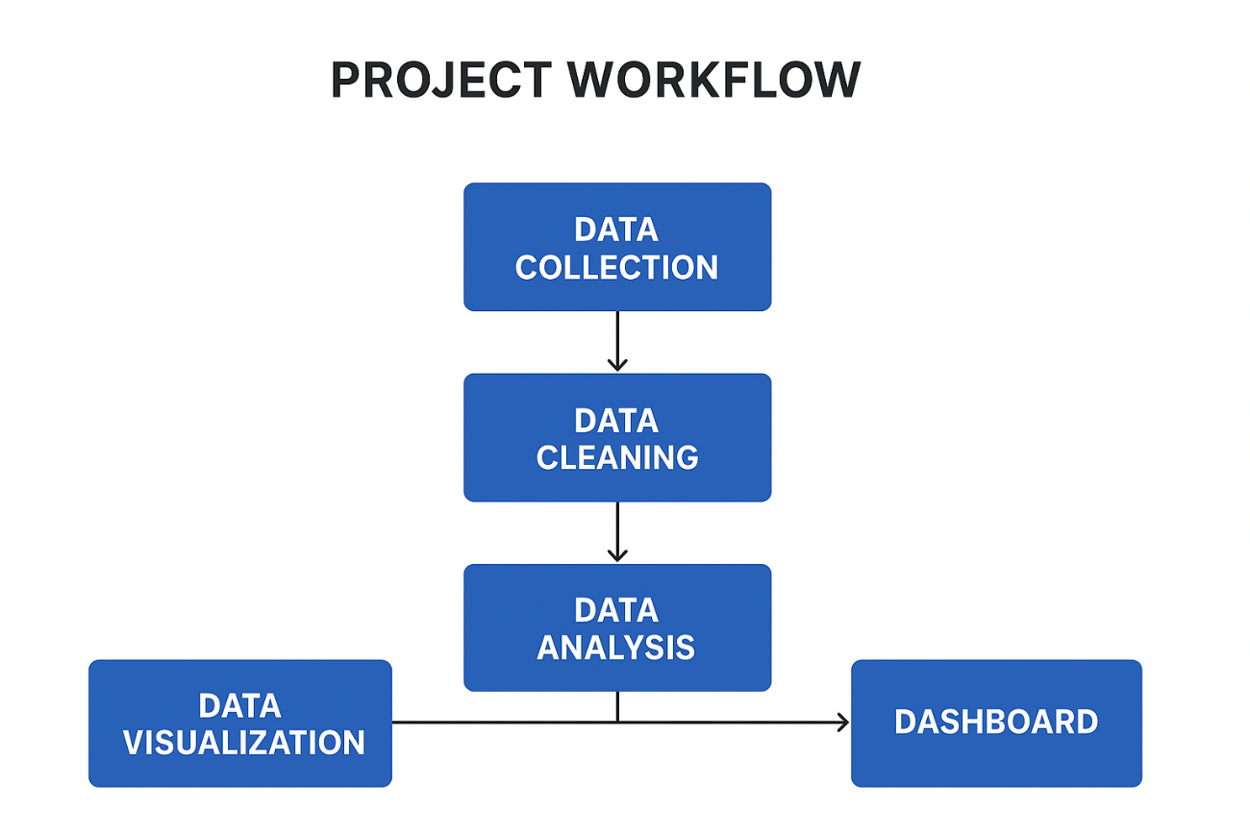
- Dashboard Creation:
Finally, the results and visualizations are integrated into an interactive Streamlit dashboard, allowing users to view tables, charts, and insights dynamically.

- IMPLEMENTATION CODE

5.1 Importing Libraries
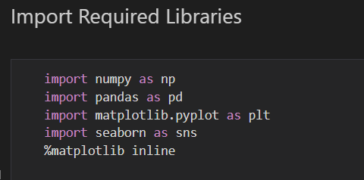

5.2 Data Handling and Cleaning
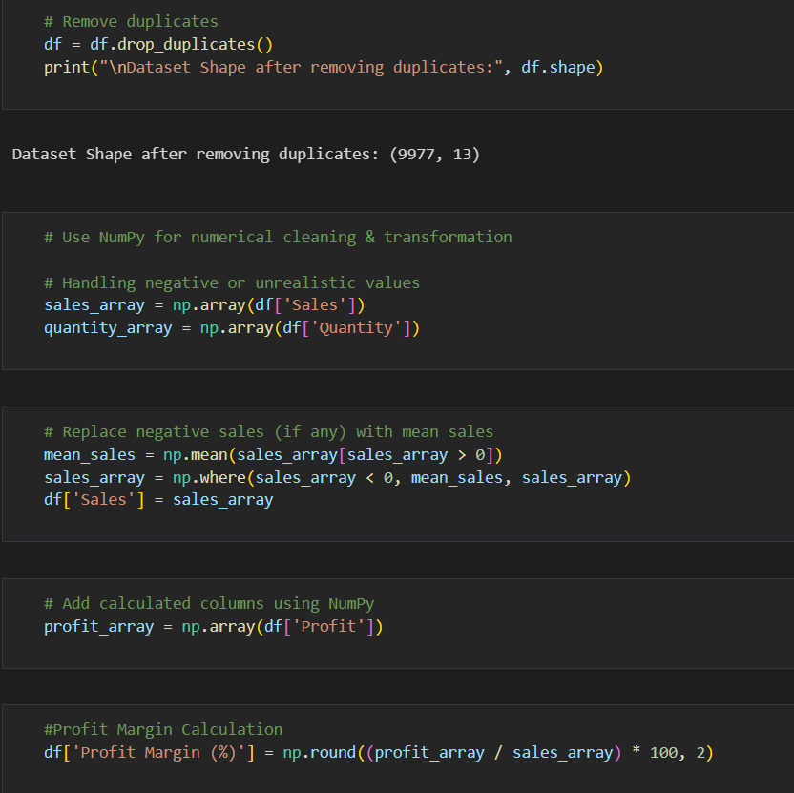
5.3 Exploratory Data Analysis
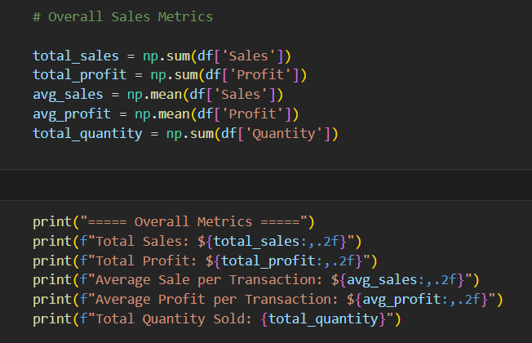
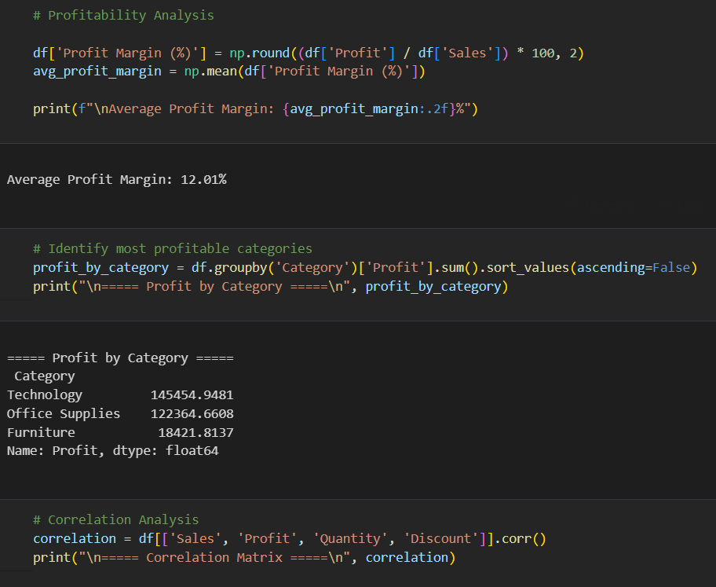
5.4 Visualizations and Insights
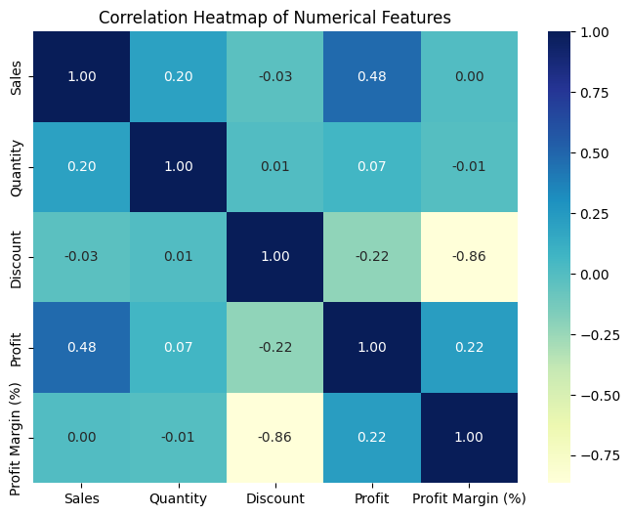
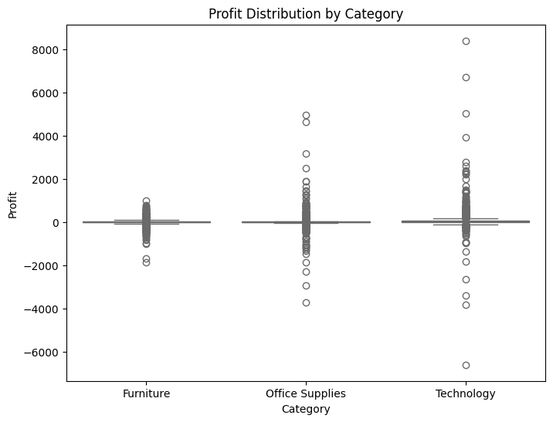
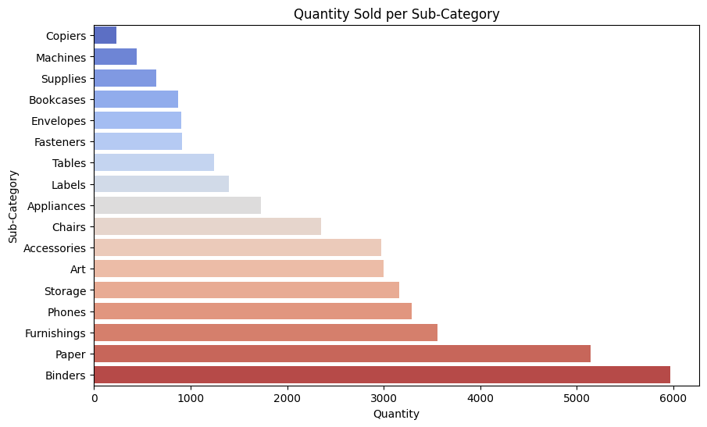
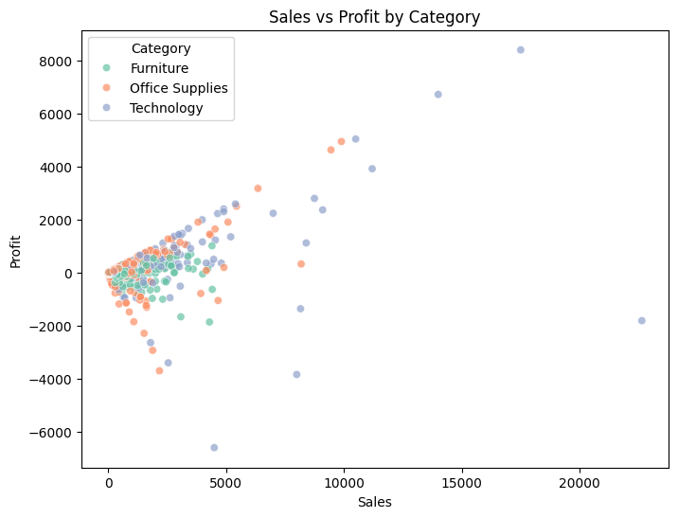
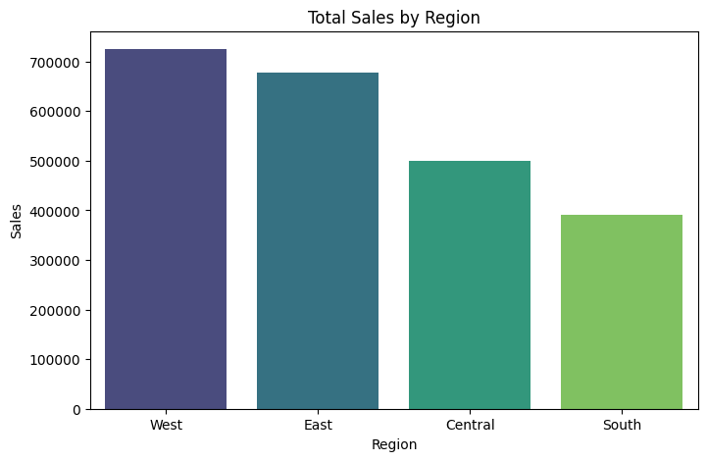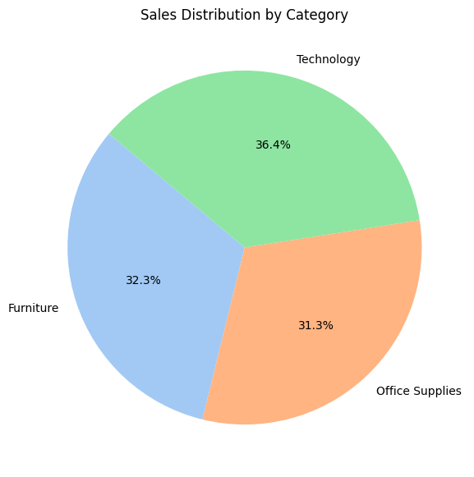

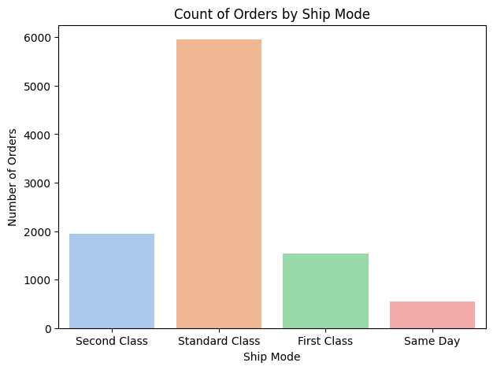
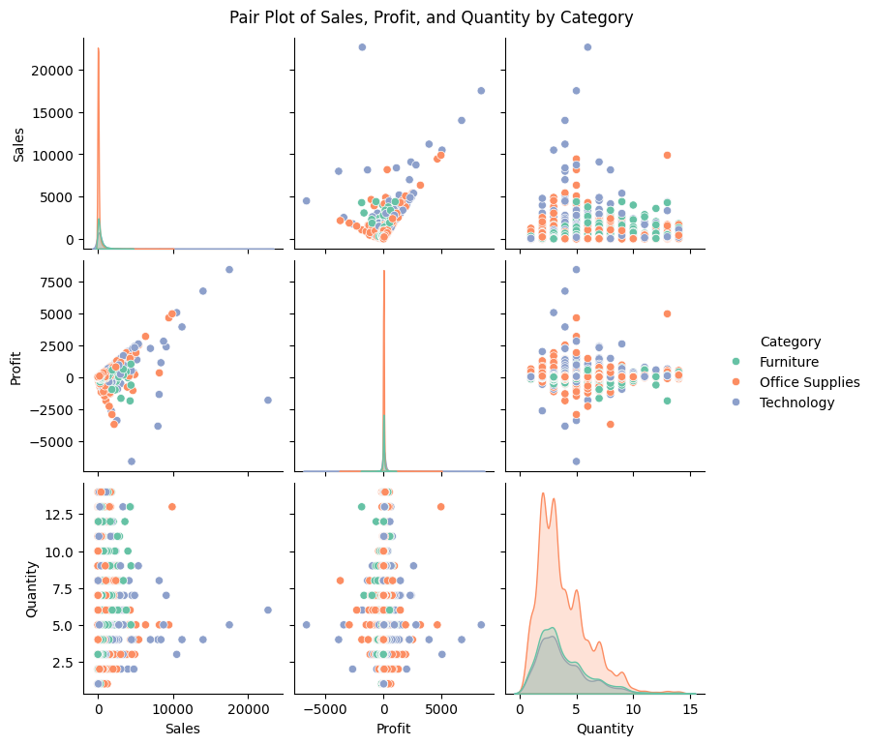
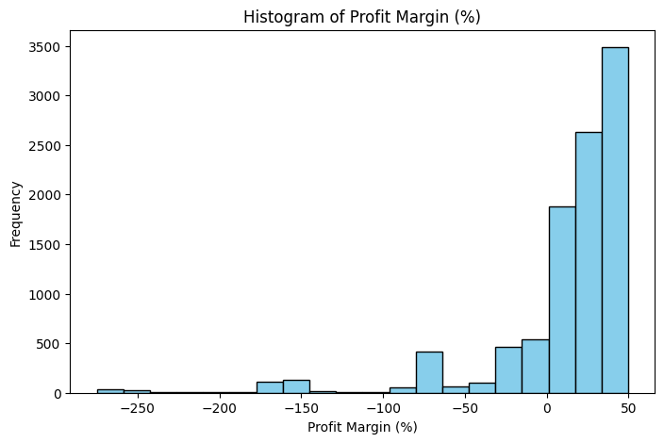
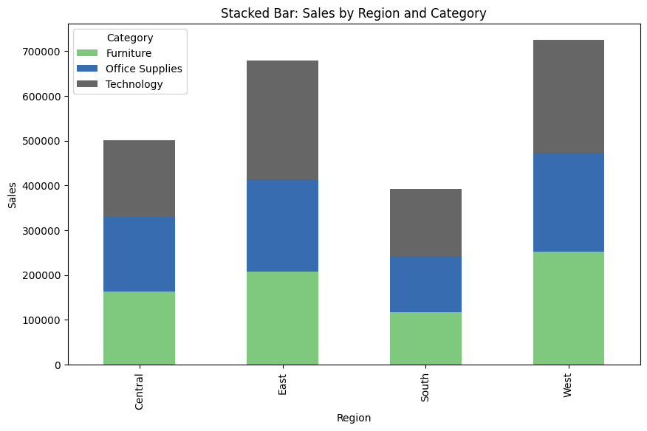

- RESULTS AND INSIGHTS

6.1 Key Visualizations
After implementing the project and performing data analysis, several meaningful visualizations were generated to represent sales performance and insights. Some of the key plots included:
- Bar Chart: Showed total sales across product categories, identifying Technology as the top-performing category.
- Line Chart: Displayed sales and profit trends, helping to observe variations in performance.
- Pie Chart: Illustrated the distribution of sales by region and segment.
- Histogram: Represented profit margin distribution, indicating most transactions with moderate margins.
- Correlation Heatmap: Showed relationships between numerical features like Sales, Profit, and Discount.
- Stacked Bar Chart: Compared regional performance across multiple product categories.
All visualizations were integrated into a Streamlit dashboard, making them interactive and easy to interpret.

6.2 Observations and Insights
From the visual and analytical results, the following key insights were observed:
- The Technology category contributed the highest revenue, while Furniture showed moderate sales but lower profit margins.
- The West Region generated the highest sales among all regions.
- A negative correlation was found between Discount and Profit, meaning higher discounts reduced profit significantly.
- The Consumer segment had the largest share of total sales compared to Corporate and Home Office segments.
- Most profitable transactions occurred in regions with a balanced discount policy and steady sales growth.
These insights demonstrate how Python-based analysis can effectively summarize large sales data into meaningful business conclusions.

- CONCLUSION AND FUTURE SCOPE

7.1 Summary of the Project
The Sales Analysis Dashboard project successfully demonstrates the use of Python for analyzing and visualizing real-world business data. Using the Sample Superstore Dataset, the project covered essential steps of data handling, cleaning, analysis, and visualization.
Through this project, static and interactive dashboards were developed using Matplotlib and Streamlit, which helped in understanding sales performance across different categories, regions, and customer segments. The project also provided valuable insights into how discounts and sales strategies impact overall profitability.

7.2 Key Learnings
While developing this project, several important technical and analytical concepts were learned:
- Efficient data cleaning and manipulation using Pandas and NumPy.
- Application of Matplotlib for creating professional and informative data visualizations.
- Integration of visual results into a Streamlit dashboard for better interactivity and user engagement.
- The importance of exploring relationships between sales, profit, and discount to understand business performance.
This project enhanced both analytical thinking and practical programming skills in Python.

7.3 Future Enhancements
Although the project achieved its main goals, it can be further improved in the future by:
- Adding time-series data to analyze sales trends over different months or years.
- Implementing predictive models using machine learning to forecast future sales and profits.
- Expanding the dashboard with interactive filters and real-time data updates.
- Connecting the application with a database to allow dynamic data input and storage.
Such improvements can make the dashboard a more powerful and intelligent tool for business decision-making.

- REFERENCES
• Dataset Source:
Sample Superstore Dataset – Available on Kaggle (used for educational and analysis purposes).
• Python Documentation:
https://docs.python.org/3/ – Official Python documentation for language syntax and standard libraries.
• Pandas Library:
https://pandas.pydata.org/ – For data manipulation, cleaning, and analysis.
• NumPy Library:
https://numpy.org/ – For numerical computations and array operations.
• Matplotlib Library:
https://matplotlib.org/ – For creating static data visualizations.
• Streamlit Framework:
https://streamlit.io/ – For developing interactive web-based dashboards.
• Additional Learning Resources:
- W3Schools Python Tutorials – https://www.w3schools.com/python/
- GeeksforGeeks – Python Data Analysis and Visualization Articles

